Step 4: Classification and Features

- Download UDAT
To analyze the files, we will use the UDAT program. To perform the analysis, we will need to download UDAT to our computers. The files can be downloaded from
http://people.cs.ksu.edu/~lshamir/downloads/udat/
the folder contains these files:

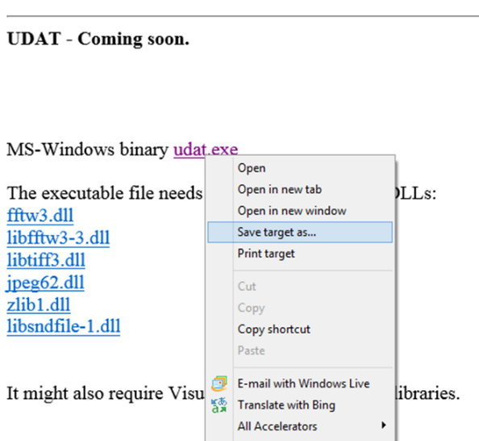

You will need to right click the file “udat.exe” and choose “Save target as…” or “Save link as…” and save the file in your hard drive. For convenience, it is better to name the folder “udat”.
When you download the file, your browser might not recognize the file and might therefore give you a warning.
In that case, you should click “Actions” and then select “download anyway”. The file is safe to download and is certainly not malicious.

Then, you will need to right click the .dll files and save them in the same folder where you downloaded “udat.exe”. The files that you need to download and save are:

udat.exe
fftw3.dll
libfftw3-3.dll
libtiff3.dll
jpeg62.dll
zlib1.dll
libsndfile-1.dll

Your UDAT folder should look something like this:
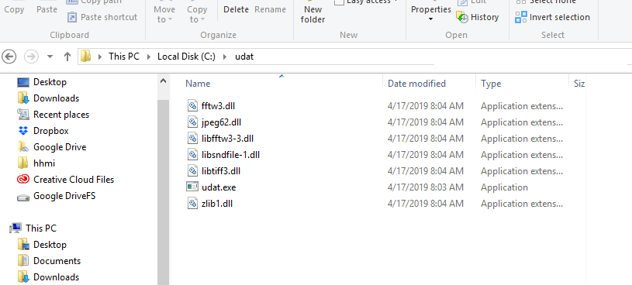

- Compute the text features
After UDAT is installed, we can use UDAT to convert each text file to a set of numerical descriptors. The command line that will compute the numerical descriptors for each text file is the following:

udat compute -m c:\path\to\root\folder c:\path\to\any\folder\output.fit
(It is preferred not to copy and paste the command because some characters might change).

The path “c:\path\to\root\folder“ is the root path of the classes folders, and the output file “output.fit” can be created anywhere on the hard drive, but it is convenient to create it in the same folder.
After the file names will be displayed on the screen, the file “output.fit” will be created in the “c:\path\to\any\folder” folder.
The “-m” switch allows to run several UDAT processes in parallel, but also creates a .sig file for each text file. That .sig file contains important information about the numerical features that describe each text file.

- Classification

udat test -f0.05 -i1604 -j688 -n10 -w C:\Users\Prath\her\output.fit
Classification using UDAT can be done by using the following command:

udat test -f0.35 -i1000 -j30 -n10 -w c:\path\to\output\output.fit

“-f0.35” tells UDAT to use the 35% most informative numerical content descriptors (features).
“-i1000” and “-j30” means that 1000 text files from each class will be used for training and 30 will be used for testing.
“-n10” tells UDAT to repeat the experiment 10 times, such that in each run different text files will be randomly allocated to training and test sets (bootstrapping).
“-w” means that UDAT will use the Weighted Nearest Distance (WND) pattern recognition method.

The command above should run in almost all Windows terminals. In some terminals the command line might not run. In that case, run “.\udat” instead of “udat”. You might also need to use quotes around the -f attribute and run “.\udat “-f0.35” -i1000 -j30 -n10 -w”.

When running, UDAT will show the files that are being classified, their class ID and their predicted class ID. If the class ID and the predicted class ID are the same, the classification of that text file is correct.

Given the command line, UDAT will test 30 text files per class in each of the 10 runs, and when done will show the average classification accuracy of the text files. When done, it will show the classification accuracy.

Now, we can change the number of features that we use by changing the value of the “-f” switch. For instance, to use 55% of the numerical image content descriptors we can use the following command line:

udat test -f0.55 -i1000 -j30 -n5 -w c:\path\to\output\output.fit
udat test -f0.4 -i1000 -j141 -n10 -w C:\Users\Prath\her\output.fit
Low_Artists Top_Artists
Low_Artists 98 43
Top_Artists 28 113
Accuracy: 0.748227 Average accuracy (10 splits): 0.732270
udat test -f0.5 -i1000 -j141 -n10 -w C:\Users\Prath\her\output.fit
Low_Artists Top_Artists
Low_Artists 84 57
Top_Artists 22 119
Low_Artists Top_Artists
Low_Artists 1.00000 0.79790
Top_Artists 0.72369 1.00000
Accuracy: 0.719858
Average accuracy (10 splits): 0.721277

udat test -f0.05 -i1000 -j141 -n10 -w C:\Users\Prath\her\output.fit
Low_Artists Top_Artists
Low_Artists 93 48
Top_Artists 27 114
Low_Artists Top_Artists
Low_Artists 1.00000 0.59825
Top_Artists 0.62137 1.00000
Accuracy: 0.734043
Average accuracy (10 splits): 0.724113
udat test -f0.6 -i1000 -j141 -n10 -w C:\Users\Prath\her\output.fit
Low_Artists Top_Artists
Low_Artists 89 52
Top_Artists 29 112
Low_Artists Top_Artists
Low_Artists 1.00000 0.76232
Top_Artists 0.73885 1.00000
Accuracy: 0.712766
Average accuracy (10 splits): 0.727660
udat test -f0.8 -i1000 -j141 -n10 -w C:\Users\Prath\her\output.fit
Low_Artists Top_Artists
Low_Artists 82 59
Top_Artists 24 117
Low_Artists Top_Artists
Low_Artists 1.00000 0.74691
Top_Artists 0.70250 1.00000
Accuracy: 0.705674
Average accuracy (10 splits): 0.715957
udat test -f2.0 -i1000 -j141 -n10 -w C:\Users\Prath\her\output.fit
Low_Artists Top_Artists
Low_Artists 90 51
Top_Artists 27 114
Low_Artists Top_Artists
Low_Artists 1.00000 0.75606
Top_Artists 0.76605 1.00000
Accuracy: 0.723404
Average accuracy (10 splits): 0.732624
udat test -f2.5 -i1000 -j141 -n10 -w C:\Users\Prath\her\output.fit
Low_Artists Top_Artists
Low_Artists 88 53
Top_Artists 31 110
Low_Artists Top_Artists
Low_Artists 1.00000 0.74406
Top_Artists 0.77089 1.00000
Accuracy: 0.702128
Average accuracy (10 splits): 0.720922
udat test -f3.0 -i1000 -j141 -n10 -w C:\Users\Prath\her\output.fit

Low_Artists Top_Artists
Low_Artists 79 62
Top_Artists 27 114
Low_Artists Top_Artists
Low_Artists 1.00000 0.83189
Top_Artists 0.73959 1.00000
Accuracy: 0.684397
Average accuracy (10 splits): 0.715248
>udat test -f3.5 -i1000 -j141 -n10 -w C:\Users\Prath\her\output.fit
Low_Artists Top_Artists
Low_Artists 88 53
Top_Artists 26 115
Low_Artists Top_Artists
Low_Artists 1.00000 0.74824
Top_Artists 0.74087 1.00000
Accuracy: 0.719858
Average accuracy (10 splits): 0.727660
udat test -f4.0 -i1000 -j141 -n10 -w C:\Users\Prath\her\output.fit
Low_Artists Top_Artists
Low_Artists 84 57
Top_Artists 28 113
Low_Artists Top_Artists
Low_Artists 1.00000 0.75788
Top_Artists 0.73186 1.00000
Accuracy: 0.698582
Average accuracy (10 splits): 0.731560
>udat test -f4.5 -i1000 -j141 -n10 -w C:\Users\Prath\her\output.fit
Low_Artists Top_Artists
Low_Artists 95 46
Top_Artists 28 113
Low_Artists Top_Artists
Low_Artists 1.00000 0.73970
Top_Artists 0.74088 1.00000
Accuracy: 0.737589
Average accuracy (10 splits): 0.723759
udat test -f5.0 -i1000 -j141 -n10 -w C:\Users\Prath\her\output.fit
Low_Artists Top_Artists
Low_Artists 86 55
Top_Artists 28 113
Low_Artists Top_Artists
Low_Artists 1.00000 0.77230
Top_Artists 0.74985 1.00000
Accuracy: 0.705674
Average accuracy (10 splits): 0.720922
udat test -f5.5 -i1000 -j141 -n10 -w C:\Users\Prath\her\output.fit
Low_Artists Top_Artists
Low_Artists 85 56
Top_Artists 29 112
Low_Artists Top_Artists
Low_Artists 1.00000 0.77820
Top_Artists 0.73846 1.00000
Accuracy: 0.698582
Average accuracy (10 splits): 0.736170
udat test -f6.0 -i1000 -j141 -n10 -w C:\Users\Prath\her\output.fit
Low_Artists Top_Artists
Low_Artists 85 56
Top_Artists 20 121
Low_Artists Top_Artists
Low_Artists 1.00000 0.79340
Top_Artists 0.73826 1.00000
Accuracy: 0.730496
Average accuracy (10 splits): 0.730496
udat test -f6.5 -i1000 -j141 -n10 -w C:\Users\Prath\her\output.fit
Low_Artists Top_Artists
Low_Artists 91 50
Top_Artists 22 119
Low_Artists Top_Artists
Low_Artists 1.00000 0.76069
Top_Artists 0.73741 1.00000
Accuracy: 0.744681
Average accuracy (10 splits): 0.739007
udat test -f6.5 -i1000 -j141 -n05 -w C:\Users\Prath\her\output.fit

Low_Artists Top_Artists
Low_Artists 92 49
Top_Artists 20 121
Low_Artists Top_Artists
Low_Artists 1.00000 0.77028
Top_Artists 0.73451 1.00000
Accuracy: 0.755319
Average accuracy (5 splits): 0.748227

udat test -f1.0 -i1000 -j141 -n10 -w C:\Users\Prath\her\output.fit
Low_Artists Top_Artists
Low_Artists 88 53
Top_Artists 32 109
Low_Artists Top_Artists
Low_Artists 1.00000 0.72567
Top_Artists 0.78062 1.00000
Accuracy: 0.698582
Average accuracy (10 splits): 0.729787
udat test -f1.5 -i1000 -j141 -n10 -w C:\Users\Prath\her\output.fit
Low_Artists Top_Artists
Low_Artists 89 52
Top_Artists 26 115
Low_Artists Top_Artists
Low_Artists 1.00000 0.76530
Top_Artists 0.75091 1.00000
Accuracy: 0.723404
Average accuracy (10 splits): 0.726241
udat test -f0.1 -i1000 -j141 -n10 -w C:\Users\Prath\her\output.fit
Low_Artists Top_Artists
Low_Artists 89 52
Top_Artists 24 117
Low_Artists Top_Artists
Low_Artists 1.00000 0.64129
Top_Artists 0.68163 1.00000
Accuracy: 0.730496
Average accuracy (10 splits): 0.732624
udat test -f0.15 -i1000 -j141 -n10 -w C:\Users\Prath\her\output.fit
Low_Artists Top_Artists
Low_Artists 96 45
Top_Artists 30 111
Low_Artists Top_Artists
Low_Artists 1.00000 0.69231
Top_Artists 0.72608 1.00000
Accuracy: 0.734043
Average accuracy (10 splits): 0.727305
udat test -f0.3 -i1000 -j141 -n10 -w C:\Users\Prath\her\output.fit
Low_Artists Top_Artists
Low_Artists 93 48
Top_Artists 22 119
Low_Artists Top_Artists
Low_Artists 1.00000 0.74099
Top_Artists 0.69859 1.00000
Accuracy: 0.751773
Average accuracy (10 splits): 0.728723

This is what i got at last after training many times, and results.html was generated after this..udat test -f6.0 -i1000 -j141 -n10 -w -p C:\Users\Prath\her\output.fit C:Users\Prath\her\results.html
Low_Artists Top_Artists
Low_Artists 87 54
Top_Artists 19 122
Low_Artists Top_Artists
Low_Artists 1.00000 0.75694
Top_Artists 0.75262 1.00000
Accuracy: 0.741135
Average accuracy (10 splits): 0.746454

Exercise 1:
Run the same command with “-f0.05”, “-f0.1”, “-f0.15”, “-f0.3”, “-f0.4”, “-f0.5”.
The optimal portion of features in the experiment is: _________
The best classification accuracy is: _________
The confusion matrix is:

Visualize your results by preparing a graph (e.g., Using Excel). The x-axis of the graph is the amount of features, and the y-axis is the classification accuracy.

How does the portion of features used affect the classification accuracy? Why do you think that happens?

We can also ask UDAT to create a detailed report file showing the results of the experiment. That will be done by using the “-p” switch, and specifying another file in the end of the command line:

udat test -f0.55 -i1000 -j30 -n10 -w -p c:\path\to\output\output.fit c:\path\to\output\results.html

The file “results.html” will provide a detailed report on the experiment. To open the report file, just double click it and it will be open in your default browser.
Results.html is generated

Exercise 2:
Open the report file and click on the label “Toggle feature names” to open the most informative features. The seven most informative features are:
Feature description | Fisher discriminant score

Run the same command with “-f0.05”, “-f0.1”, “-f0.15”, “-f0.3”, “-f0.4”, “-f0.5”.
The optimal portion of features in the experiment is: _________
The best classification accuracy is: _________

Please visualize your results by preparing a graph. The x-axis of the graph is the amount of features, and the y-axis is the classification accuracy.

Exercise 3:
Open the report file and click on the label “feature means” and find the features you used in Exercise 2. The means of the feature values are:
Feature description | Class 1 (D) | Class 2 (R)

Run the same command with “-f0.05”, “-f0.1”, “-f0.15”, “-f0.3”, “-f0.4”, “-f0.5”.
The optimal portion of features in the experiment is: _________
The best classification accuracy is: _________

Please visualize your results by preparing a graph. The x-axis of the graph is the amount of features, and the y-axis is the classification accuracy.

Exercise 4:
Based on the features identified in Exercises 2 and 3, what new things can we learn about political speeches?

